MR. CHINMAY R. HATE
An Application for the position suitable with my Qualification in HDFC Bank.
Contact:-  Cell o1 : 9967430546  Cell o2 [In Emergency] : 8655560651  Email 01 : chinmayhate@gmail.com  Email 02 : hatechinmay@gmail.com  SKYPE : chinmay.hate  Linded In : chinmayhate@gmail.com | 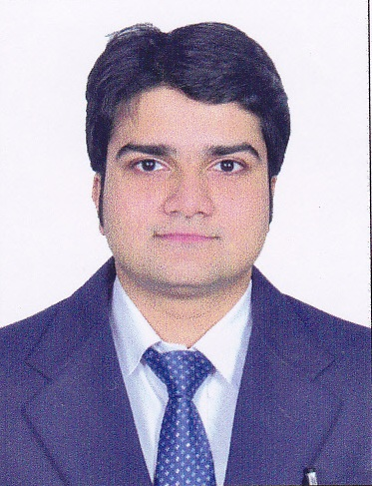

[1] Executive Summary of the CV:
- A Finance Management Professional with an approach of constant ‘Learner’
- Focused career plan in the Finance Management Aspects
- Open to accept the challenges in Personal & Professional Life
- Systematic, Disciplined and Organized approach
- A T3 manager [Team/ Time and Task Manager]
[2] Track Record:-
- Accounts Executive at TechnNaren Stanzerei Pvt. Ltd. (May 2009 - June 2011)
- Completed 02 months as summer Intern with UCO Bank in Treasury & Forex Mgmt.
- Business Development Manager at GroomWell Associates (April 2013 - March 2014)
- Assistant Manager at Axis Bank since April 2014
[3] Academic Achievements:-
- M.M.S. [Finance Specialization] in 2013 [Mumbai University- Bharati Vidyapeeth] .Stood overall 3rd in the College.
- B.Com. in 2009 [Mumbai University - R.A.PODAR]
[4] Add on Skills:-
GNIT [Basic Course] | NCFM Modules of Banking & Currency Derivatives cleared.

[5] Academic Projects:-
Research on "Depreciating Rupee : Euro Crises or India's Internal Failure" | Integrated treasury Management | "Team leader" of CSR Project in Karjat (Overall development of adivasis)
[6] Achievements in Personal & Academic Aspects:-
Attended Military training camp in 2006. | "Team Leader" for 13 hikes of Podars’ hikers club. | Best Hiker of the year 2008(R.A.PODAR). | Best Hiker of the year (Certificate & gold medal) 2009 (R.A.Podar) & TRESURER Podar Hikers Club
LIGHTS OF PODAR (2009) (Certificate & Trophy.) | Actively participated and asked questions in AGM of TATA STEEL & CHEMICALS 2012. | Personally asked questions to Mr RATAN TATA in the AGM of TATA CHEMICALS. | Attended 6th Supply chain CONCLAVE held at TAJ LAND's.
Attended 5th brand loyalty summit & awards 2012 held at INTERCONTINENTAL THE LALIT. | "Head" of organizing committee for Industrial Visit 2012 of B.V.I.M.S.R | Best student(Male) Industrial visit of B.V.I.M.S.R. 2012. | Was in the news for Conservation of forts in Maharashtra
[7] Salary / Notice Period/ References:-
Salary: In person pl. | Reference: In person pl. | Notice Period : 90 days
[8] Personal Details:-
Date of Birth :27/09/1988 Age: 26 Yrs Height : 5ft 9 inch Weight:72kg Health: Sound Spects: Nil Driving License No : 20070004951 IT Pan Number : AEKPH3195R Passport Number : H7705515 Adhar Card : 812756920096 | Family Details :  Native Place : Mumbai  Own Accomodation  Parents: Service
CHINMAY R HATE
[Signature] Date:- 24/04/2015

